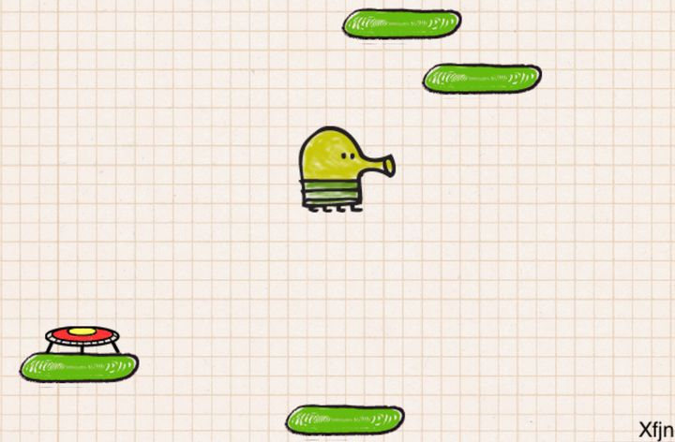

Hello Lizzie!

Today James started working on Sketch Head! This is a recreation of one of my favourite mobile games of all time, Doodle Jump!!  
  
We started off by making a 2D template and downloading some preset assets into it. The first asset we used was the background, we dragged it into the Main Camera so it would become a child of it, before also getting our player SketchHead.  
  
Once James set these up so the correct one would be in front he then used a 2D rigid body and box collider, this allowed us to set the gravity and to detect hitbox collisions, we also used the box collider in our platforms as well as a platform effector to create one way collision.  
  
The next step was to start our player controller script. James started off by making two public float variables for our moveSpeed and jumpForce, before moving onto a private variable to define our rigidbody (this allows us to access the SketchHead through the script). Then we made a start method that is similar to functions that run when the game starts from white - Green Belt, in this we attached our rigidbody to our script!  
  
Next we made a FixedUpdate method, this is similar to the update method from earlier belts that runs constantly at set intervals. In unity we made the left arrow cause a value of -1 while the right arrow gives +1 in the horizontal axis, this can then be used to calculate our movement and then we stored it in a float (thats a number variable)!  
  
We lastly looked at an onCollisionEnter2D method which runs when our player object touches the top side of the platform. We firstly checked to see if our character was currently moving downwards to touch the platform, if true then it'll add some jump force to give us more power!  
  
Finally we simply added the scripts into the objects that needed them and Voila! Doodle Jump!! Great work today James, only one more game to go!!!!